# MARAPLACE- Marketplace for Migration Agents

## CLIENT-SIDE FEATURES

1**. User Registration & Profile**

* Sign up / log in (email, phone, Google, Apple)
* Personal profile with saved documents and communication history

**2. Search & Filter Agents**

* By visa type (student, skilled, partner, employer-sponsored, etc.)
* By location (Australia-wide or by state/city)
* By language spoken
* By MARA registration number (optional verification)

**3. Agent Profiles**

* Bio, specializations, languages
* MARA registration (verified badge)
* Pricing (hourly, flat fees, consultation)
* Available time slots for bookings
* Reviews and ratings

**4. Booking System**

* Schedule appointments (online or in-person)
* Calendar integration (Google, Apple)
* Reschedule / cancel options

**5. Messaging System**

* Secure in-app messaging
* File sharing (documents, forms, ID)
* Automated follow-ups / reminders

**6. Payment System**

* Secure payment gateway (Stripe, PayPal, Afterpay if needed)
* Option to pay per consultation or in packages
* Refund and cancellation policy display

**7. Client Dashboard**

* Upcoming appointments
* Status of applications (if agent offers tracking)
* Payment history
* Saved agents / favourites

## MIGRATION AGENT FEATURES

**1. Agent Registration & Verification**

* Upload MARA certificate, business documents
* Profile moderation by admin

**2. Custom Profile Setup**

* Add services offered (visas, appeals, skills assessments, etc.)
* Set consultation fees and availability
* Upload intro video or qualifications

**3. Booking & Calendar Management**

* Accept/reject bookings
* Set availability
* Sync with external calendar tools

**4. Client Management Tools**

* View client details, chat, notes
* Upload/download documents
* Mark tasks as complete
* Send automated follow-ups

**5. Earnings Dashboard**

* Track income
* Payout requests (manual or auto via Stripe)
* Invoice generation

**6. Review Management**

* Respond to reviews
* Track rating trends

## PLATFORM ADMIN FEATURES

**1. User & Agent Moderation**

* Approve/deny agents
* Flag and manage inappropriate content or users
* Remove unverified agents

**2. Dispute Resolution Centre**

* Handle complaints from both sides
* Offer refund mediation or credit compensation

**3. Analytics Dashboard**

* Agent performance
* Popular services
* Revenue tracking

**4. Email & Notification Management**

* Appointment reminders
* Promotional messages
* Follow-up templates

## MONETIZATION IDEAS

* Commission per booking (e.g., 10–15% of agent fee)
* Subscription model for agents (basic free, premium with extra features)
* Featured agent listing (pay to appear at top)
* Ad placements (relevant services like document prep, health checks, IELTS)

## LEGAL & COMPLIANCE

* Display agent MARA numbers
* Terms and conditions for users and agents
* Privacy policy and data handling procedures
* Identity verification for both clients and agents (KYC, optional)

**Other Features Include AI Chatbot**

## **P**rocess Flow Diagram

## Architecture Diagram

## ER Diagram

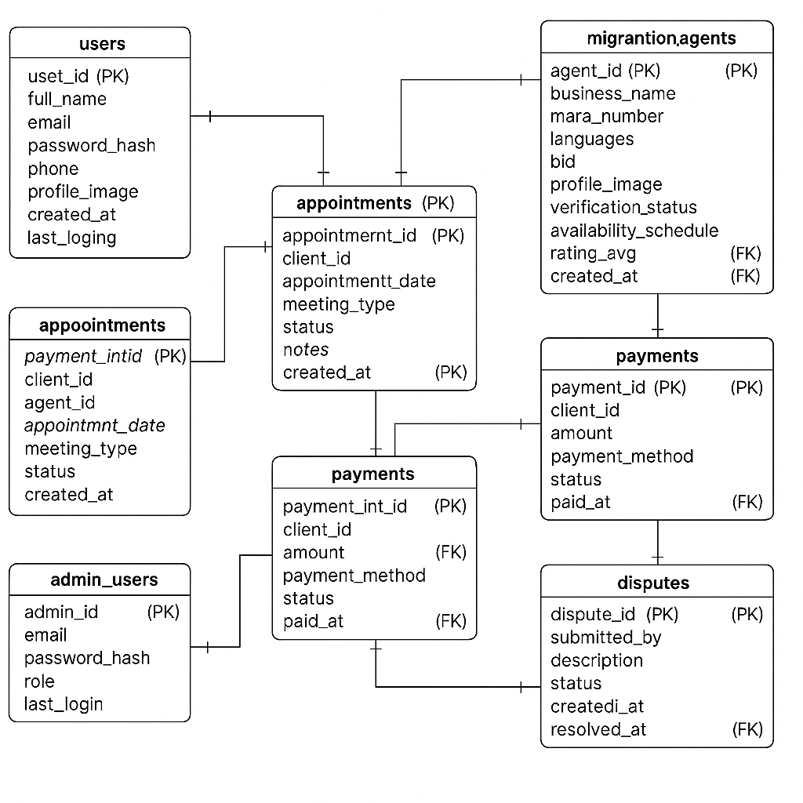

## Wireframe of basic features for MARA Agents

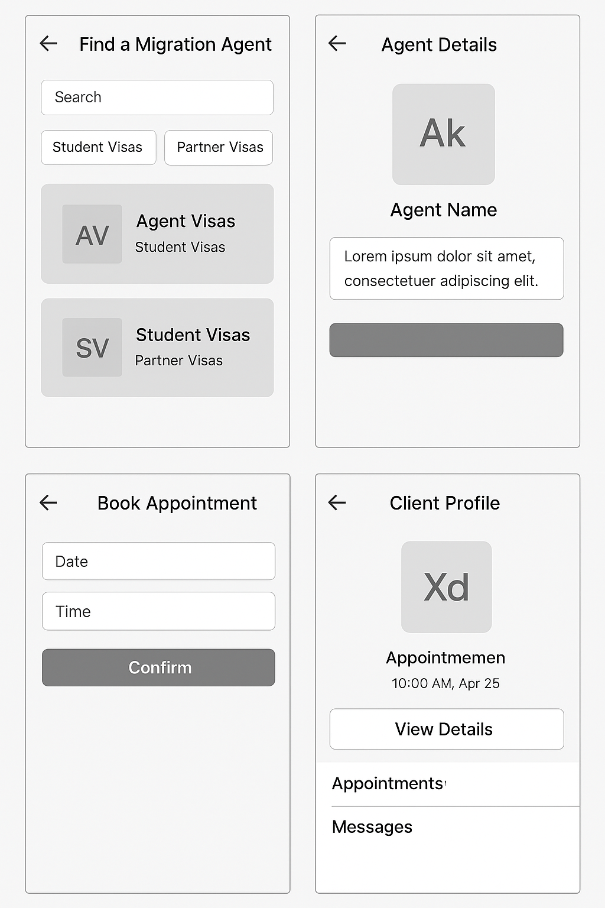Wireframe for Clients

# Database Tables & Attributes

**1. Users (clients)**

| **Field Name** | **Data Type** | **Description** |
| --- | --- | --- |
| user_id | INT (PK) | Primary Key, auto-increment |
| full_name | VARCHAR(100) | User’s full name |
| email | VARCHAR(100) | Unique email address |
| password_hash | VARCHAR(255) | Encrypted password |
| phone | VARCHAR(20) | Contact number |
| profile_image | VARCHAR(255) | Path to profile image |
| created_at | TIMESTAMP | Date of registration |
| last_login | TIMESTAMP | Last login time |

**2. Migration_agents**

| **Field Name** | **Data Type** | **Description** |
| --- | --- | --- |
| agent_id | INT (PK) | Primary Key |
| user_id | INT (FK) | FK to users (agent is also a user) |
| business_name | VARCHAR(100) | Company or trading name |
| mara_number | VARCHAR(50) | MARA registration number |
| languages | VARCHAR(255) | Languages spoken (comma-separated) |
| bio | TEXT | Description of services |
| profile_image | VARCHAR(255) | Image URL |
| verification_status | ENUM | 'pending', 'verified', 'rejected' |
| availability_schedule | JSON | Availability calendar |
| rating_avg | DECIMAL(2,1) | Average review score |
| created_at | TIMESTAMP | Date joined as agent |

**3. Appointments**

| **Field Name** | **Data Type** | **Description** |
| --- | --- | --- |
| appointment_id | INT (PK) | Primary Key |
| client_id | INT (FK) | FK to users |
| agent_id | INT (FK) | FK to migration_agents |
| appointment_date | DATETIME | Scheduled date and time |
| meeting_type | ENUM | 'online', 'in-person' |
| status | ENUM | 'booked', 'completed', 'cancelled', 'rescheduled' |
| notes | TEXT | Client/agent notes |
| created_at | TIMESTAMP | When the booking was made |

**4. Payments**

| **Field Name** | **Data Type** | **Description** |
| --- | --- | --- |
| payment_id | INT (PK) | Primary Key |
| appointment_id | INT (FK) | FK to appointments |
| client_id | INT (FK) | FK to users |
| agent_id | INT (FK) | FK to migration_agents |
| amount | DECIMAL(10,2) | Fee paid |
| payment_method | ENUM | 'card', 'paypal', 'stripe' |
| status | ENUM | 'pending', 'paid', 'failed', 'refunded' |
| paid_at | TIMESTAMP | When payment was completed |

**5. Reviews**

| **Field Name** | **Data Type** | **Description** |
| --- | --- | --- |
| review_id | INT (PK) | Primary Key |
| appointment_id | INT (FK) | FK to appointments |
| client_id | INT (FK) | FK to users |
| agent_id | INT (FK) | FK to migration_agents |
| rating | INT | Score out of 5 |
| comment | TEXT | Optional written feedback |
| created_at | TIMESTAMP | When review was submitted |

**6. Admin_users**

| **Field Name** | **Data Type** | **Description** |
| --- | --- | --- |
| admin_id | INT (PK) | Primary Key |
| email | VARCHAR(100) | Admin login email |
| password_hash | VARCHAR(255) | Encrypted password |
| role | ENUM | 'superadmin', 'moderator' |
| last_login | TIMESTAMP | Last access |

s**7. Disputes**

| **Field Name** | **Data Type** | **Description** |
| --- | --- | --- |
| dispute_id | INT (PK) | Primary Key |
| appointment_id | INT (FK) | FK to appointments |
| submitted_by | ENUM | 'client', 'agent' |
| description | TEXT | Complaint detail |
| status | ENUM | 'open', 'resolved', 'closed' |
| created_at | TIMESTAMP | Submitted date |
| resolved_at | TIMESTAMP | Optional field when resolved |